Driftless in Wisconsin
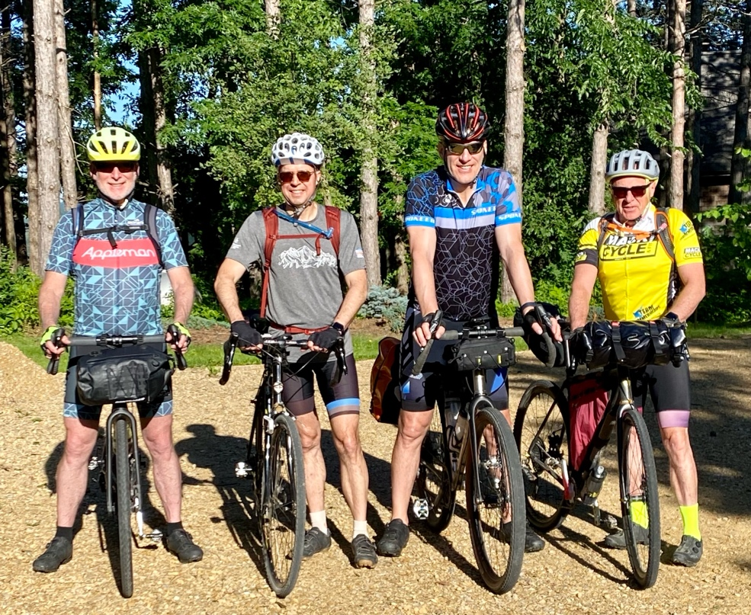
We rode 85 miles and climbed 4,500 ft for more than six hours on a mix of gravel & road descending the Mississippi River valley from Stockholm Wisconsin to Winona Minnesota.
This was Day 1 of a three day “gravel” ride took us deep into the Driftless region. To a geologist Driftless refers to the Ice Age and glaciers for a rider it meant valleys, bluffs and the river accompanied by nine steep climbs.
First breakfast was a hearty affair of steel cut oats and strong coffee. Then the quatuor of Kevin, Galen, Tomaz and I shoved off from “On the Edge” the Shrivers home perched on the bluffs overlooking a bend in the Mississippi River, immediately faced with a daunting descent followed by a grueling climb on crushed gravel, we were into the ride and within the first half hour silently questioning our sanity.
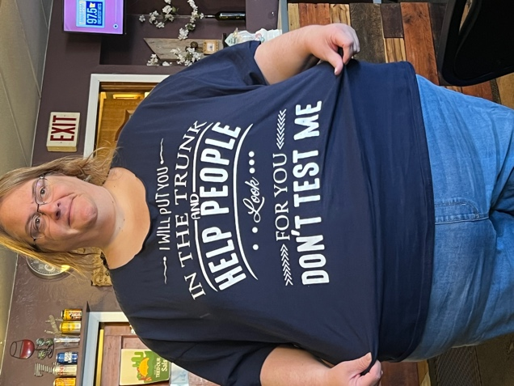
Our first stop was for a second breakfast at 10:30 at Perkz Cafe in Durand, Wi. We met a large mother of five kids aged 17 to 7 who were assigned matching red T-Shirts with ascending numbers Thing 1, Things 2 and so on. She offered to throw us in the trunk of her car with her children. The banter continued as we inhaled eggs and pancakes with real maple syrup.
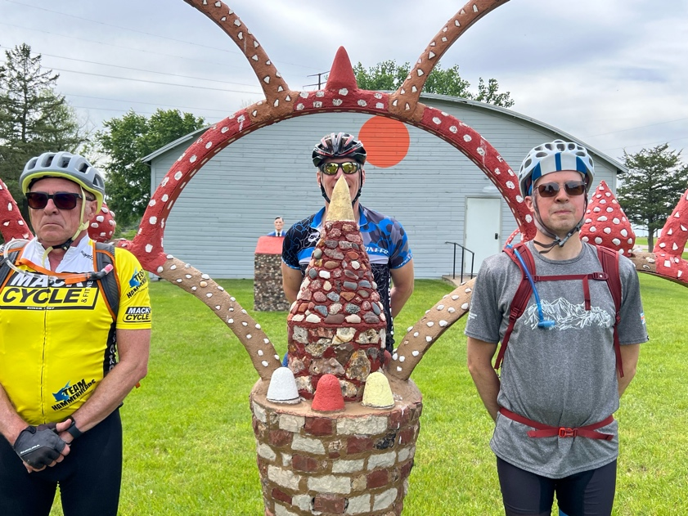
Other highlights were the spectacular valley vistas from the bluffs, followed by exhilarating albeit slightly terrifying descents and then the long steep climbs. Shout out to Matt for building such a damn good bike. Lots of climbing gears. The hardest climb was the ninth and last. In Alma we picked up the southbound River Rd.
Northwestern breeze pushed us down river on Hwy 35. Road past small-town summer festival preparations. At Fontaine City, Kevin (being Kevin) propositioned two local ladies innocently sitting on a bench. Another highlight was the backwater “cut out” off Hwy 35, which led us directly to the truly bizarre Prairie Moon Sculpture Garden.
The last mile had us crossing the river to the Minnesota side. Within moments of arrival at the VRBO, the owners father drove over to check us out and offer a ride into town. Showers and laundry before walking to ZAZ’s Pizza & Beer. To our delight we were served by Katie Winona State Senior majoring in Architecture and business with a delightful smile. She brought us hand tossed pizza and beers, which we ordered one at a time just to watch her walk away.

